LAMPIRAN

TAMPILAN – TAMPILAN WEB
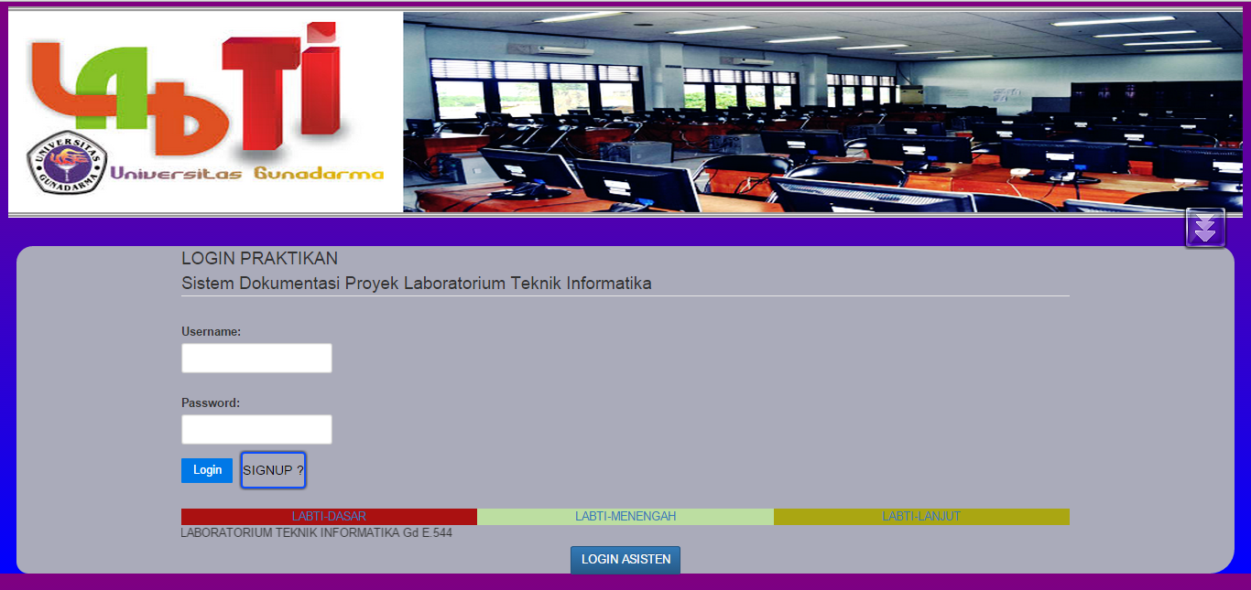

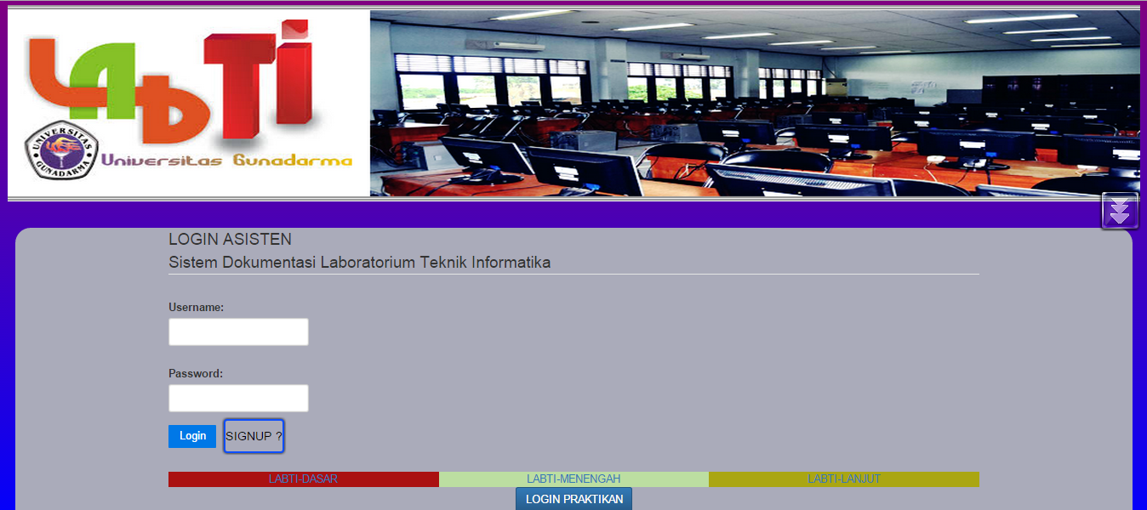

Halaman Login Praktikan

Halaman Login Asisten

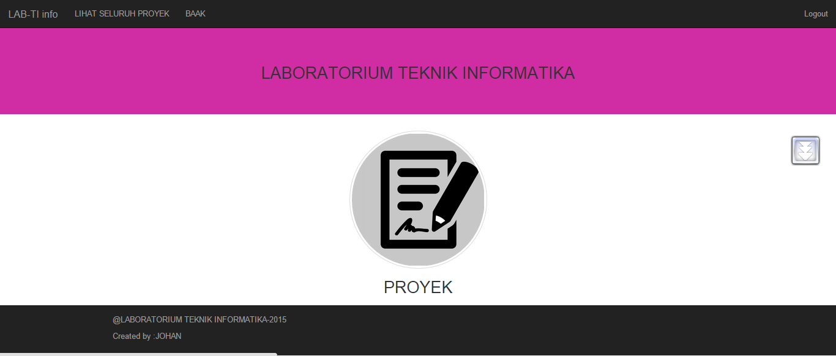
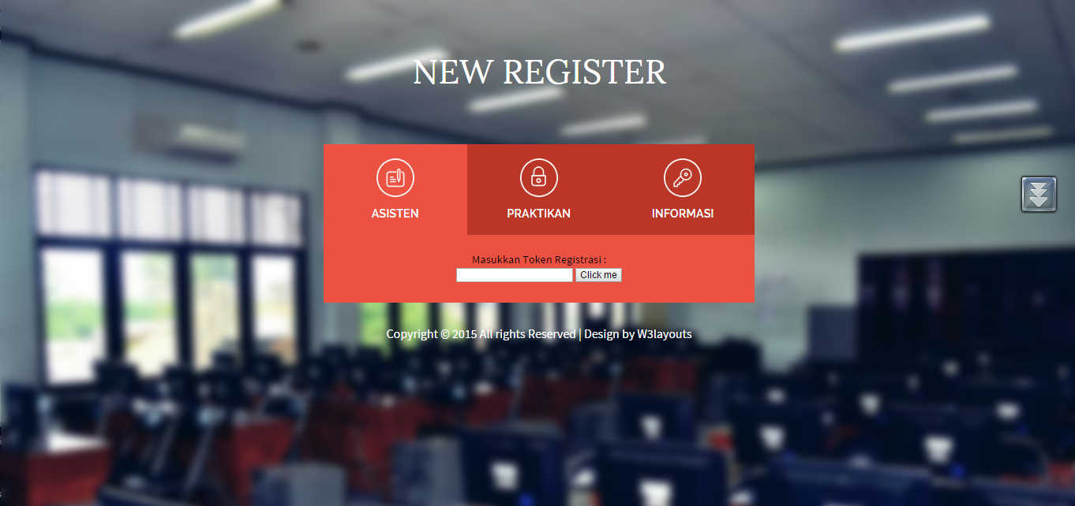
Halaman Register

Halaman Menu Utama

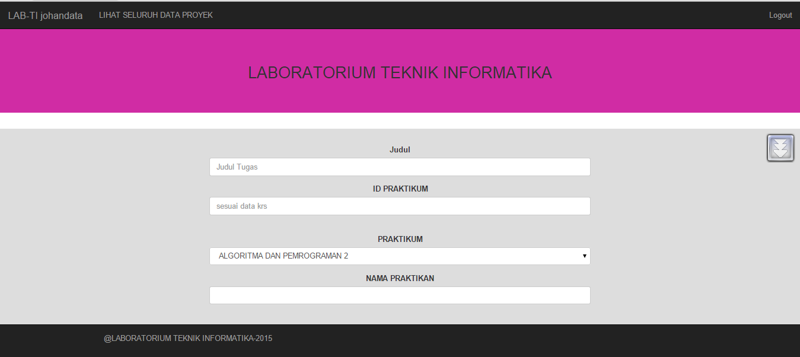


Halaman Input Data Proyek

Halaman Pesan Sukses

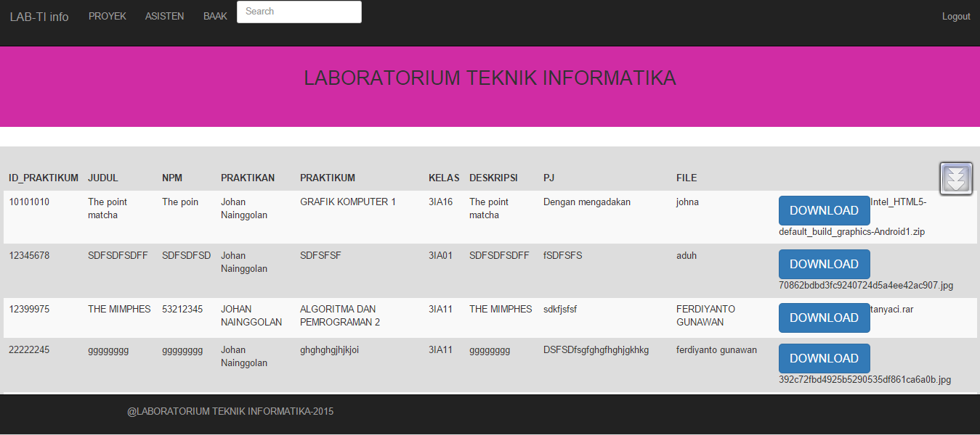
Halaman Tampilan Data Proyek

Listing Baris Program
lab_ctr.php :
<?php if ( ! defined('BASEPATH')) exit('No direct script access allowed');
session_start(); //Memanggil fungsi session Codeigniter
class Lab_ctr extends CI_Controller
{
function index()
{
if($this->session->userdata('logged_in'))
{

$session_data = $this->session->userdata('logged_in');
$data['username'] = $session_data['username'];
$data['dispstat'] = $session_data['status'];

$this->load->view('mainmenu' , $data);
}
else
{
//Jika tidak ada session di kembalikan ke halaman login
redirect('Lab_ctr/login_index', 'refresh');
}
}
function login_index()
{
if($this->session->userdata('logged_in'))
{
redirect('Lab_ctr', 'refresh');
}
else
{
$this->load->helper(array('form'));
$this->load->view('vlab_login');
}
}

function logout()
{
$this->session->unset_userdata('logged_in');
session_destroy();
redirect('Lab_ctr/login_index', 'refresh');
}

//function view signup
function signupform(){
$this->load->view('v_signuptoken');
} function insertPraktikan()
{ $this->load->model('labti_model');
$this->labti_model->m_insPraktikan();
$this->load->view('v_signuptoken');
}

public function do_upload()
{
$config = array(
'upload_path' => './kumpulan/',
'allowed_types' => '*',
'max_size' => '6000',
'encrypt_name' => false,
);
$this->load->library('upload', $config);
if (!$this->upload->do_upload()) {

$this->gotoTugasPage();
}
else
{
$upload_data = $this->upload->data();
$judul=$this->input->post('judul');
$id_praktikum=$this->input->post('id_praktikum');

$praktikum=$this->input->post('nama_praktikum');

$varnama=$this->input->post('nama_praktikan');

$deskripsi=$this->input->post('deskripsi');

$npm=$this->input->post('npm');

$peje=$this->input->post('listAsisten');
$kelas=$this->input->post('kelas');
$tanggal=$this->input->post('datethis');

$data_ary = array(
'id_praktikum'=> $id_praktikum,
'judul' => strtoupper($judul),
'npm' => $npm,
'tanggal' => $tanggal,
'nama_praktikan'=> strtoupper($varnama),
'nama_praktikum'=> strtoupper($praktikum),
'kelas' => strtoupper($kelas),
'deskripsi' => $deskripsi,
'penanggung_jawab' => strtoupper($peje),
'file_name' => $upload_data['file_name'],
);
$this->load->database();
$this->db->insert('upload', $data_ary);

$this->gotoSuksesPage();
}
}

function insertAsisten()
{

$this->load->model('labti_model');
$cekmodel= $this->labti_model->m_insAsisten();
echo "Model Berhasil Memasukkan data asisten";
}
public function asisten_upload()
{
$config = array(
'upload_path' => './kumpulanAsisten/',
'allowed_types' => '*',
'max_size' => '2048',
'overwrite' => true,
'encrypt_name' => false,
);
$this->load->library('upload', $config);
if (!$this->upload->do_upload()) {
$this->goAsistenPage();
}
else
{

$upload_data = $this->upload->data();

$ids= $this->input->post('nid');
$nmas= $this->input->post('nama');
$almt = $this->input->post('alamat');
$port = $this->input->post('portofolio');
$email = $this->input->post('email');
$lsm= $this->input->post('linksocmed');
$kontak = $this->input->post('kontak');
$jab = $this->input->post('jabatanstruktural');
$thnmasuk = $this->input->post('tahunmasuk');
$data_ary = array(
'id_asisten'=> $ids,
'nama_asisten' =>strtoupper($nmas),
'alamat' => strtoupper($almt),
'portofolio'=> $port,
'email'=> $email,
'linksocmed' => $lsm,
'kontak' => $kontak,
'jabatan_struktural'=> strtoupper($jab) ,
'tahun_masuk'=> $thnmasuk,
'filename_photo' => $upload_data['file_name'],
);
$this->load->database();
$this->db->insert('arsip_asisten', $data_ary);
$this->goAsistenPage();
}
}
function verifikasiToken()
{ $input=$this->input->post('inputToken');
$token="labti12345"; if ($input==$token)
{ $this->load->view('v_signup');
}else
{
redirect('Lab_ctr','refresh');
}
}
function lihatsemua()
{ if($this->session->userdata('logged_in'))
{ $session_data = $this->session->userdata('logged_in');
$data['username'] = $session_data['username'];
$data['namaku'] = $session_data['nama'];
$data['kontak'] = $session_data['kontak'];
$this->load->view('lihat_semua',$data); }
else
{ redirect('Lab_ctr','refresh'); } }
public function dataproyek()
{
if($this->session->userdata('logged_in'))
{
$session_data = $this->session->userdata('logged_in');
$data['username'] = $session_data['username'];
$data['namaku'] = $session_data['nama'];
$data['kontak'] = $session_data['kontak'];
$this->load->view('form_proyek',$data); }
else { redirect('Lab_ctr','refresh'); }}
public function gotoTugasPage(){ if($this->session->userdata('logged_in'))
{
$session_data = $this->session->userdata('logged_in');
$data['username'] = $session_data['username'];
$data['dispstat'] = $session_data['status'];
$data['dispnpm'] = $session_data['npm'];
//$data['dispnip'] = $session_data['nip'];
$data['namaprak'] = $session_data['nama_praktikan'];
$this->load->library('upload');
$data['error']=$this->upload->display_errors();
$data['query']=$this->labti_model->getPost();
$this->load->view('tugas_page',$data); }
else {
redirect('Lab_ctr/login_index', 'refresh'); }}
public function gotoSuksesPage(){
if($this->session->userdata('logged_in'))
{
$session_data = $this->session->userdata('logged_in');
$data['username'] = $session_data['username'];
$this->load->view('upload_success',$data); }
else { //Jika tidak ada session di kembalikan ke halaman login
redirect('Lab_ctr/login_index', 'refresh');
}}
public function goToLoginAsisten(){ $this->load->view('vlab_logasisten');
}
public function goAsistenPage()
{
if($this->session->userdata('logged_in'))
{
$session_data = $this->session->userdata('logged_in');
$data['username'] = $session_data['username'];
$data['dispstat'] = $session_data['status'];
$this->load->library('upload');
$data['error']= $this->upload->display_errors();
$this->load->view('arsip_asisten' , $data);
}
else
{
//Jika tidak ada session di kembalikan ke halaman login
redirect('Lab_ctr/login_index', 'refresh');
}}
public function cget_data_proyek()
{ $this->load->model('labti_model');
$data['h'] = $this->labti_model->mget_data_proyek();
$this->load->view('view_proyek',$data);
} public function cget_data_search()
{ if($this->session->userdata('logged_in'))
{
$session_data = $this->session->userdata('logged_in');
$data['username'] = $session_data['username'];
$data['dispstat'] = $session_data['status'];
//load the database
$this->load->database();
//load the model
$this->load->model('labti_model');
//load the method of model
$data['h']=$this->labti_model->mget_data_search();
//return the data in view
$this->load->view('view_proyek',$data);
}
}

function downloadProjek($file)
{
$this->load->helper('download');
$file_data = file_get_contents(base_url()."kumpulan/".$file);
$file_name = $file;
force_download($file_name, $file_data);
}

public function gotoMainMenu(){ $this->login_index();}
public function goToLoginPraktikan(){ $this->load->view('vlab_login');
}
public function c_viewproyek(){ if($this->session->userdata('logged_in')) {
$session_data = $this->session->userdata('logged_in');
$data['username'] = $session_data['username'];
$data['dispstat'] = $session_data['status'];
//load the database
$this->load->database();
//load the model
$this->load->model('labti_model');
//load the method of model
$data['h']=$this->labti_model->mget_data_proyek();
//return the data in view
$this->load->view('view_proyek',$data); }}
public function c_viewasisten(){ if($this->session->userdata('logged_in'))
{
$session_data = $this->session->userdata('logged_in');
$data['username'] = $session_data['username'];
$data['dispstat'] = $session_data['status'];
$this->load->view('view_asisten',$data); } }?>
labti_model.php :
<?php
//DATABASE PASSWORD FIELD NYA KURANG PANJANG MINIMAL 50
Class Labti_model extends CI_Model
{
function loginpraktikan($username, $password)
{ $this->db->select('*');
$this->db->from('praktikan');
$this->db->where('username', $username);
$this->db->where('password', MD5($password));
$this->db->limit(1);
$query=$this->db->get();
if($query->num_rows()> 0)
{ return $query->result(); }
else { return false; } }
function loginasisten($username, $password)
{ $this->db->select('*');
$this->db->from('asisten');
$this->db->where('username', $username);
$this->db->where('password', MD5($password));
$this->db->limit(1);
$query=$this->db->get();
if($query->num_rows()> 0) { return $query->result(); }
else { return false; } }
function m_insPraktikan() {
$npm = $this->input->post('npmPraktikan');
$nama = $this->input->post('namaPraktikan');
$username = $this->input->post('usernamePraktikan');
$password =md5($this->input->post('passwordPraktikan'));
$kelas = $this->input->post('kelasPraktikan');
$email = $this->input->post('emailPraktikan');
$thn_masuk = $this->input->post('tahunPraktikan');
$status=1;
$data=array
(
'npm'=>$npm,
'nama_praktikan'=>$nama,
'email' =>$email,
'kelas' =>$kelas,
'username'=>$username,
'password'=>$password,
'angkatan' =>$thn_masuk,
'status'=>$status
);
$this->db->insert('praktikan',$data); }
function m_insAsisten() {
$nip = $this->input->post('nipAsisten');
$nama = $this->input->post('namaAsisten');
$username = $this->input->post('usernameAsisten');
$password =md5($this->input->post('passwordAsisten'));
$jabatan = $this->input->post('jabatanAsisten');
$email = $this->input->post('emailAsisten');
$thn_masuk = $this->input->post('tahunAsisten');
$status=2; $data=array
(
'nip'=>$nip,
'nama'=>$nama,
'email' =>$email,
'username'=>$username,
'password'=>$password,
'tahun_masuk' =>$thn_masuk,
'jabatan'=>$jabatan,
'status'=>$status
);
$this->db->insert('asisten',$data);
}
function getPost()
{ $query = $this->db->query("SELECT * FROM asisten");
if ($query->num_rows()>0){
return $query->result();
}
else{ return false; }}
public function mget_data_proyek()
{ $query = $this->db->get('upload');
return $query; }
public function mget_data_search(){
$match=$this->input->post('searchme');
$this->db->like('npm',$match );
$this->db->or_like('nama_praktikum', $match);
$this->db->or_like('id_praktikum', $match);
$this->db->or_like('penanggung_jawab', $match);
$this->db->or_like('nama_praktikan', $match);
$query = $this->db->get('upload');
return $query; } }?>
verifylogin.php
<?php if ( ! defined('BASEPATH')) exit('No direct script access allowed');
class Verifylogin extends CI_Controller {
function __construct()
{
parent::__construct();
$this->load->model('labti_model','',TRUE);
}
function index()
{
//Aksi untuk melakukan validasi
$this->load->library('form_validation');

$this->form_validation->set_rules('username', 'Username', 'trim|required|xss_clean');
$this->form_validation->set_rules('password', 'Password', 'trim|required|xss_clean|callback_check_database');

if($this->form_validation->run() == FALSE)
{
//Jika validasi gagal user akan diarahkan kembali ke halaman login
$this->load->view('vlab_login'); }
else
{
//Jika berhasil user akan di arahkan ke private area
redirect('Lab_ctr', 'refresh');
}
}

function check_database($password)
{
//validasi field terhadap database
$username = $this->input->post('username');
//query ke database
$result = $this->labti_model->loginpraktikan($username, $password);
//$result2 = $this->labti_model->login2($username, $password);
if($result)
{
$sess_array = array();
foreach($result as $row)
{
$sess_array = array(
'npm'=>$row->npm,
'username' => $row->username,
'nama_praktikan'=> $row->nama_praktikan,
'alamat'=>$row->alamat,
'email'=>$row->email,
'thn_masuk'=>$row->tahun_masuk,
'status'=>$row->status
);
$this->session->set_userdata('logged_in', $sess_array);
}
return TRUE;
}
Else

{
$this->form_validation->set_message('check_database', 'Invalid username or password');
return false;
}
}
}

?>

